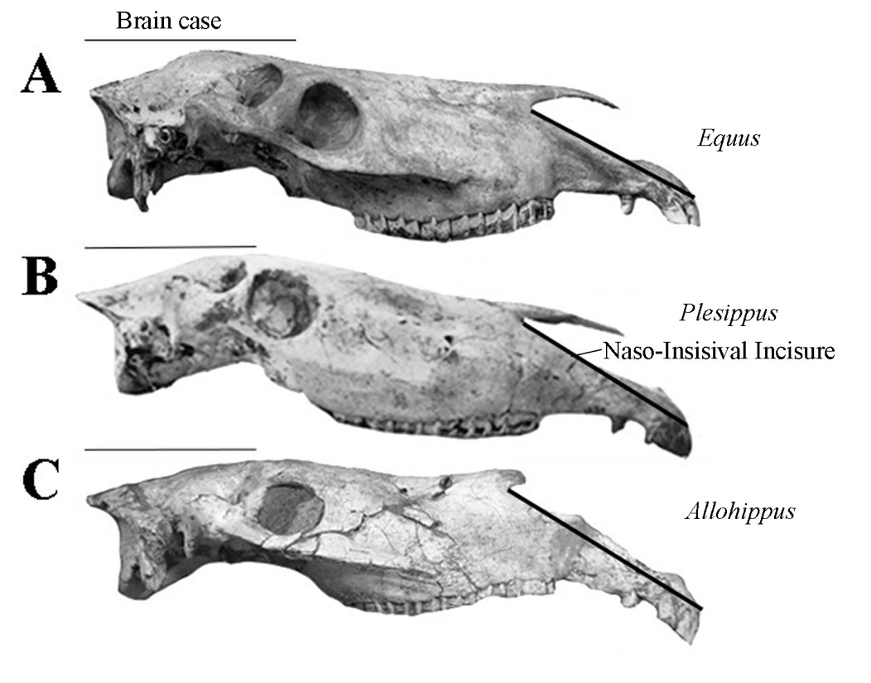

Figure S1. Profiles of Equid crania. A: *E. (Equus) caballus*, MS 96872; B: *Plesippus shoshonensis*, LACM 210-17047; C: *Allohippus vireti*, QSV 240.